
Lab Title
Button-Controlled LED Operations and Counters Using ATmega32
Submitted By:
Khurram Iftikhar
ID NO:
37438
Submitted To:
Sir Safee
Lab No:
05
Program:
BSCS
Submission Date:
12/12/2025

Objectives
- To understand input (button) and output (LED) interfacing using the ATmega32 microcontroller.
- To implement LED control based on button actions.
- To develop counters (increment, decrement, and toggle-based control) using button presses.
- To practice debouncing and state-based programming logic.

Tools / Software Used
- Microcontroller / ATmega32
- Proteus
- Microchip Studio
- LEDs
- Push Buttons
- 330Ω and 10k resistors
- Jumper wires

Procedure and Observation

Task 1:
LED ON when button pressed
Description:
Press PB0 → LED on PB1 turns ON.
Release → LED turns OFF.
Explanation:
- Button is connected to PB0 as input.
- LED is connected to PB1 as output.
- When PB0 is pressed → LED immediately turns ON.
- When released → LED turns OFF.

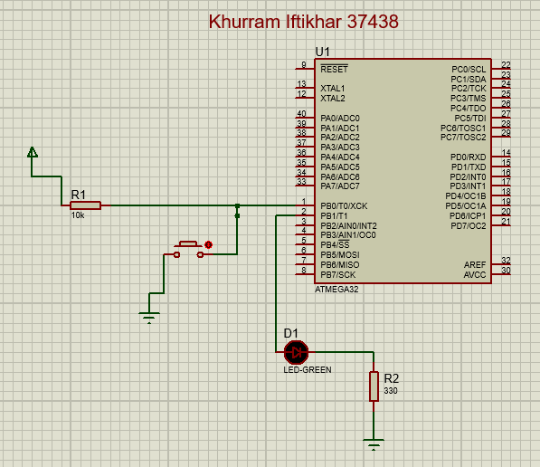
Code:

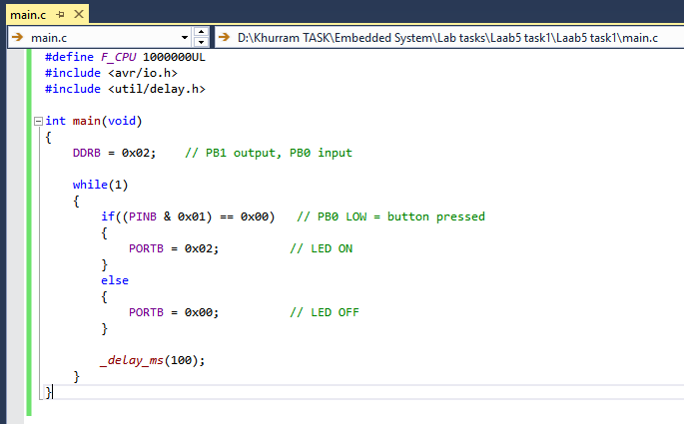

PB0 (Button) | LED (PB1) Output
0 (Released) | 0 (OFF)
1 (Pressed) | 1 (ON)

Task 2:
Toggle LED on every press
Description:
Every time button PB0 is pressed → LED PB1 toggles ON/OFF.
Explanation:
- PB0 acts as a toggle switch.
- Each press changes LED state (ON → OFF or OFF → ON).
- A state variable is used to store LED status.
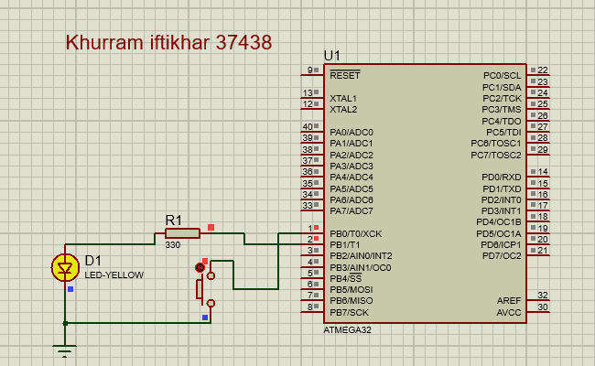
Code:
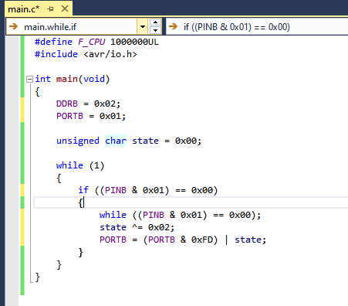

Press Number | PB0 State | LED Output
0 | Released | OFF (initial)
1 | Pressed → Released | ON
2 | Pressed → Released | OFF
3 | Pressed → Released | ON
4 | Pressed → Released | OFF
5 | Pressed → Released | ON
6 | Pressed → Released | OFF
… | … | Continues toggling

Task 3:
Make a Counter (0–255)
Description:
Add 1 to counter on every button press and display value on PORTB LEDs.
Explanation:
- Each press of PB0 increments a counter variable by 1.
- The counter value is displayed on PORTB LEDs (8-bit output).
- When it reaches 255, next increment loops back to 0.
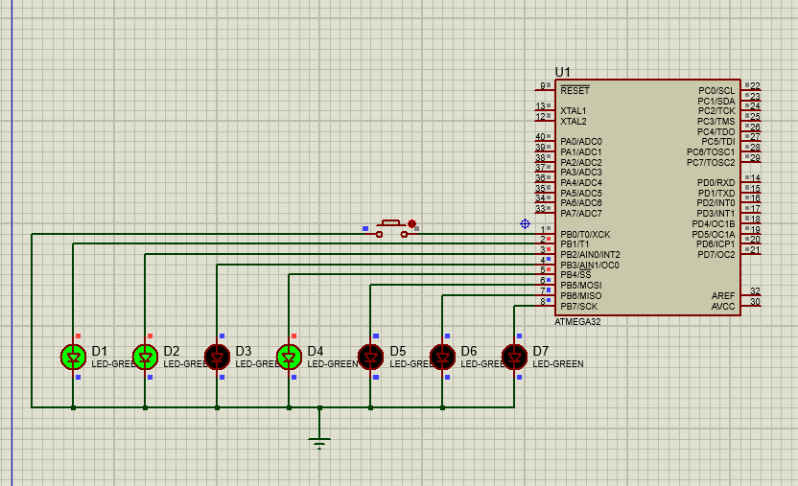
Code:
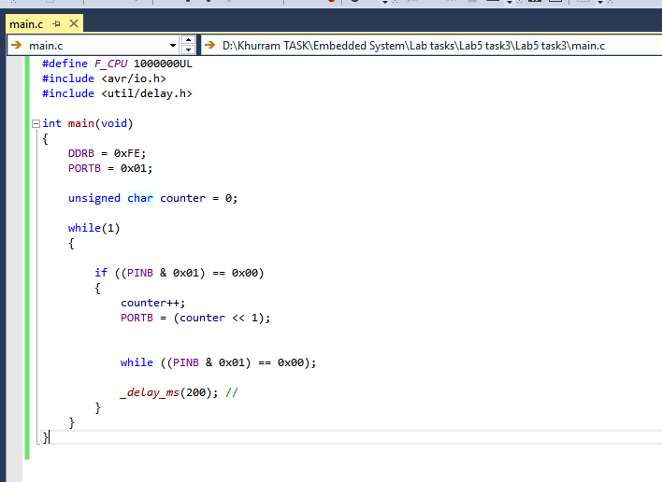

Press No. | PB0 State | Counter (Decimal) | Binary Output on LEDs
0 | Released | 0 | 0000 0000
1 | Pressed | 1 | 0000 0001
2 | Pressed | 2 | 0000 0010
3 | Pressed | 3 | 0000 0011
4 | Pressed | 4 | 0000 0100
5 | Pressed | 5 | 0000 0101
… | … | … | …
254 | Pressed | 254 | 1111 1110
255 | Pressed | 255 | 1111 1111
256 | Pressed | 0 (rollover) | 0000 0000

Task 4:
Reverse Counter
Description:
If PB0 pressed → subtract 1 from counter.
Explanation:
- PB0 is used to decrement counter by 1.
- Counter goes from 0 → 255 when subtracting below zero (due to unsigned 8-bit wrap-around).
- Value shown on PORTB LEDs.
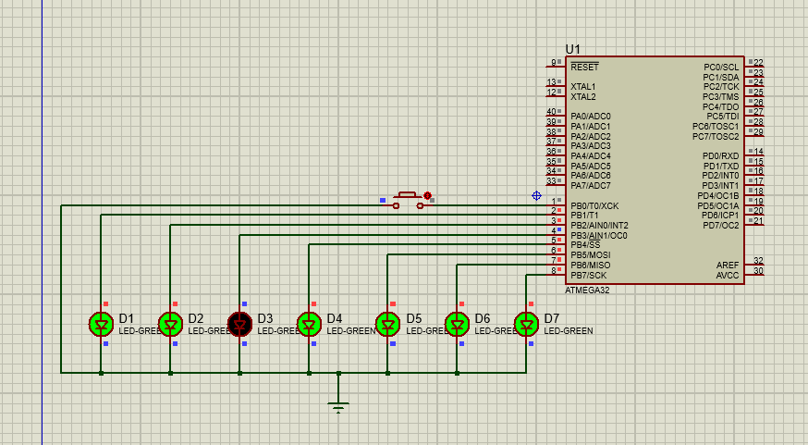
Code:
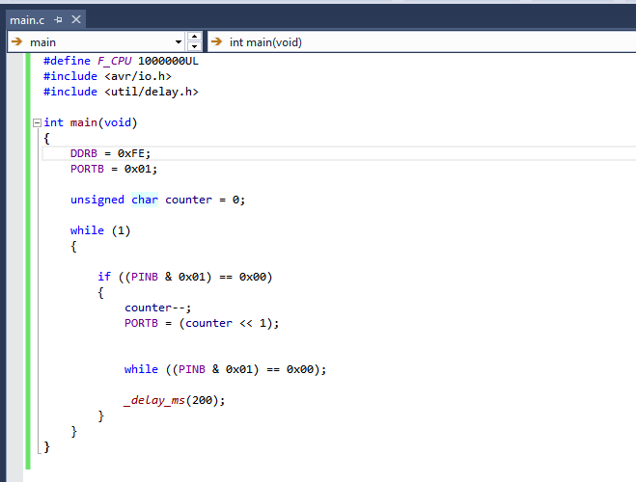

Press No. | PB0 State | Counter (Decimal) | Binary on LEDs
0 | Released | 255 | 1111 1111
1 | Pressed | 254 | 1111 1110
2 | Pressed | 253 | 1111 1101
3 | Pressed | 252 | 1111 1100
… | … | … | …
254 | Pressed | 1 | 0000 0001
255 | Pressed | 0 | 0000 0000
256 | Pressed | 255 (rollover) | 1111 1111

Task 5:
Two-button Up/Down Counter
Buttons:
• PB0 = COUNT UP
• PB1 = COUNT DOWN
LEDs on PORTB show current value.
Explanation:
- PB0 increments (COUNT UP).
- PB1 decrements (COUNT DOWN).
- PORTB displays the updated 8-bit value.
- Proper button reading and delay debounce required for accurate steps.

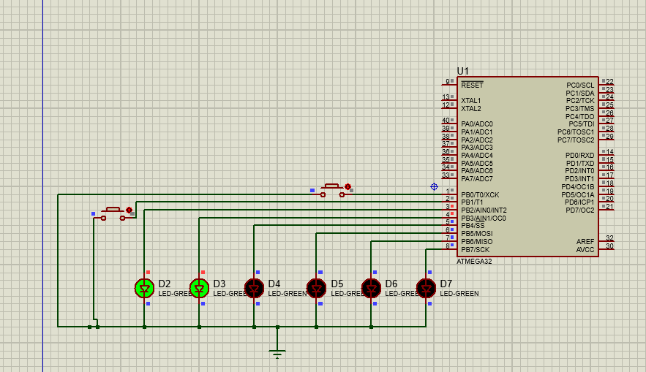
Code:
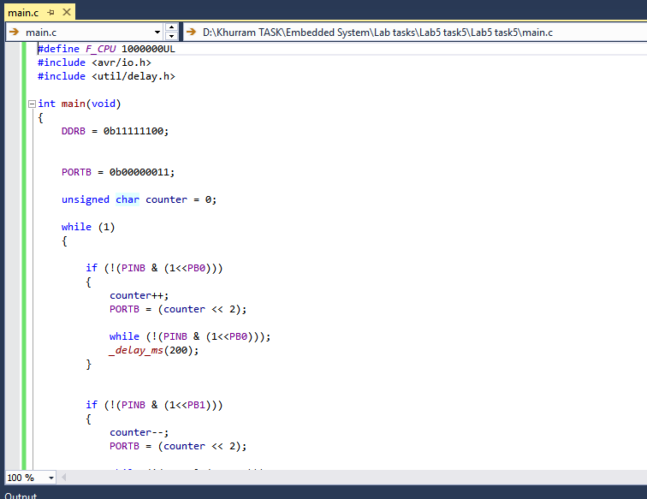
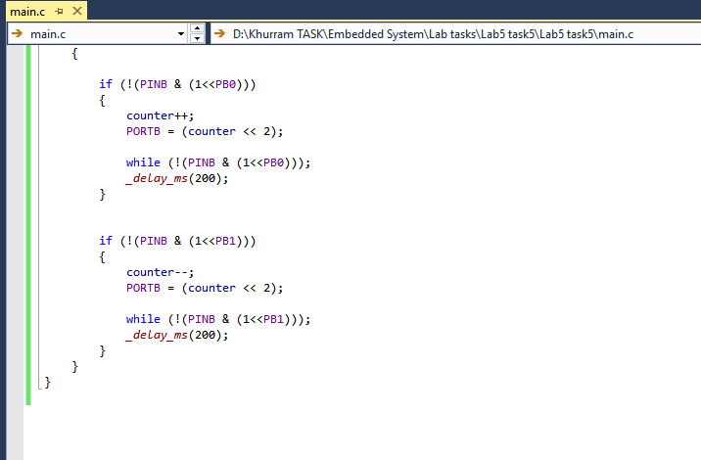

Step | PB0 | PB1 | Operation | Counter | Binary Output
0 | 0 | 0 | No press | 0 | 0000 0000
1 | 1 | 0 | Up | 1 | 0000 0001
2 | 1 | 0 | Up | 2 | 0000 0010
3 | 0 | 1 | Down | 1 | 0000 0001
4 | 1 | 1 | Ignore | 1 | 0000 0001
5 | 0 | 1 | Down | 0 | 0000 0000
6 | 0 | 1 | Down | 255 (rollover) | 1111 1111
7 | 1 | 0 | Up | 0 | 0000 0000

Results
- All tasks successfully executed and simulated.
- Button inputs effectively controlled LED outputs and counters.
- Toggle, increment, decrement, and dual-button operations worked as expected.
- PORTB correctly displayed binary values of counters

Conclusion
This lab demonstrated practical input–output control using ATmega32. By using push buttons and LEDs, multiple important programming concepts were practiced, including debouncing, toggling, increment/decrement counters, and bit-wise display on ports. The exercises strengthened understanding of microcontroller GPIO operations and state-based embedded programming.
.

